Pork & oyster stir-fry
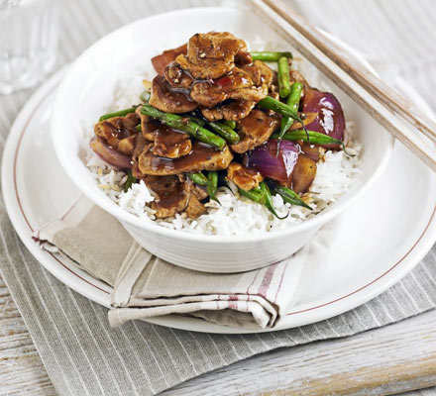
INGREDIENTS
1 tbsp lime juice
1 tbsp chilli bean paste or chilli sauce
75ml of oyster sauce
1 tsp soy sauce
2 tbsp vegetable oil
400g pork fillet, cut into thin slices
2 garlic cloves, chopped
1 red onion, cut into chunky pieces
140g green beans, halved
steamed rice or noodle, to serve

METHOD

In a small bowl, mix together the lime juice, chilli bean paste, oyster sauce and half the soy sauce. Set aside. Heat a large wok with 1 tbsp of the oil. Season the pork and toss with the remaining soy sauce. Sear the meat quickly, then remove from the pan.

Add the remaining oil and stir-fry the garlic, onion and beans for 2 mins. Return the meat to the pan with the sauce and stir-fry for another 3 mins, until the sauce has thickened. Serve with steamed rice or noodles.

