Asian pulled Chicken Salad
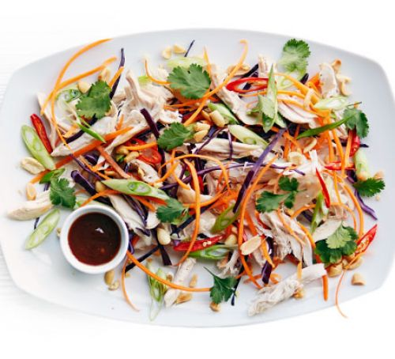
Time – Prep: 20 minutes
Ingredients - 1 small roasted chicken, about 1kg
½ red cabbage, cored and finely sliced
3 carrots, coarsley grated or finely shredded
5 spring onions, finely sliced on the diagonal
2 red chillies, halved and thinly sliced
small bunch coriander, roughly chopped, including stalks
2 heaped tbsp roasted salted peanuts, roughly crushed
For the dressing
3½ tbsp hoisin sauce
1½ tbsp toasted sesame oil

Method - Combine the dressing ingredients in a small bowl and set aside.
Remove all the meat from the chicken, shred into large chunks and pop in a large bowl. Add the cabbage, carrots, spring onions, chillies and half the coriander. Toss together with the dressing and pile onto a serving plate, then scatter over the remaining coriander and peanuts.
For more details visit - https://www.bbcgoodfood.com/recipes/asian-pulled-chicken-salad

