Malaysian Mango Chicken
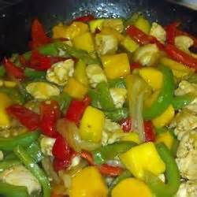
INGREDIENTS:
1 lb boneless skinless chicken breast (4 breasts)
1 red pepper
1 yellow pepper
1 green pepper
3 green onions
2 mangos
2/3 cup of chicken stock
3 tablespoons of sugar
2 tablespoons of soya sauce
2 tablespoons rice vinegar or 2 tablespoons cider vinegar
4 teaspoons of curry paste
4 teaspoons of cornflour (4 teaspoons of cold water)
4 teaspoons of vegetable oil
1 tablespoon of grated gingerroot

METHOD
- Cut chicken into three 4 inch pieces.
- Seed, core and cut peppers into 1-inch pieces.
- Slice onions into 1 1/2-inch lengths.
- Peel and pit mangoes and cut into 2/3-inch pieces.
- Whisk together stock, sugar, soy sauce, vinegar, cornflour and curry paste.
- In wok or skillet heat half of the oil over high heat; stir fry chicken for 4 minutes or until no longer pink inside.
- Transfer to plate.
- Add remaining oil to wok; stir-fry peppers for 2 minutes.
- Stir in ginger, cook for 30 seconds.
- Add stock mixture and chicken, cook stirring for 2 minutes or until sauce is thickened and chicken is hot.
- Stir in onions and mango.

