Fishy fish cakes
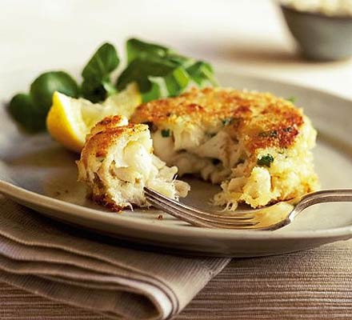

INGREDIENTS
Salmon fillets
2 bay leaves
150ml milk
350g Maris Piper potatoes
½ tsp finely grated lemon zest
1 tbsp fresh white flatleaf parsley, chopped
1 tbsp snipped chives
1 egg
flour, for shaping

METHOD

Mix all the sauce ingredients together. Set aside. Lay the fish and bay leaves in a frying pan. Pour over the milk and 150ml/¼ pint water. Cover, bring to a boil, then lower the heat and simmer for 4 mins. Take off the heat and let stand, covered, for 10 mins to gently finish cooking the fish.
Meanwhile, peel and chop the potatoes into even-sized chunks. Put them in a saucepan and just cover with boiling water. Add a pince of salt, bring back to the boil and simmer for 10 mins or until tender, but not broken up.
Lift the fish out of the milk with a slotted spoon and put on a plate to cool. Drain the potatoes in a colander and leave for a min or two. Tip them back into the hot pan on the lowest heat you can and let them dry out for 1 min, mashing them with a fork and stirring so they don't stick. You should have a light, dry fluffy mash. Take off the heat and beat in 1 rounded tbsp of the sauce, then the lemon zest, parsley and chives. Season well with salt and pepper. The potato should have a good flavour, so taste and adjust to suit.
Drain off liquid from the fish, grind some pepper over it, then flake it into big chunks into the pan of potatoes. Using your hands, gently lift the fish and potatoes together so they just mix (see pic 1). You'll only need a couple of turns, or the fish will break up too much. Put to one side and cool.
Beat the egg on a large plate and lightly flour a board. Spread the breadcrumbs on a baking sheet. Divide the fish cake mixture into four. On the floured board, and with floured hands, carefully shape into four cakes, about 2.5cm thick (pic 2). One by one, sit each cake in the egg, and brush over the top and sides so it is completely coated (pic 3). Sit the cakes on the crumbs, patting the crumbs on the sides and tops so they are lightly covered. Transfer to a plate, cover and chill for 30 mins (or up to a day ahead).
Heat the oil in a large frying pan. To test when ready, drop a piece of the dry breadcrumbs in - if it sizzles and quickly turns golden brown, it is ready to use. Fry the fish cakes over a medium heat for about 5 mins on each side or until crisp and golden.

