Cajun chicken skewers with green rice
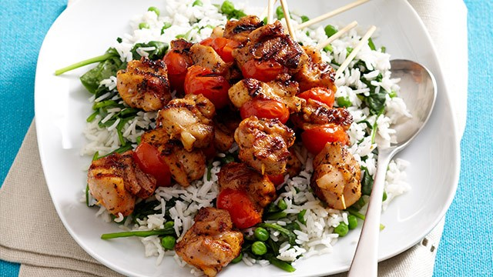

INGREDIENTS
chicken thigh fillets, 500g, cubed
olive oil, 2 tablespoons
Cajun spice mix, 1 tablespoon
cherry tomatoes, 250g punnet
bamboo skewers, 12, soaked
chicken stock, 1 1/2 cups
long-grain white rice, 3/4 cup
frozen peas, 1/2 cup, thawed
baby spinach leaves, 50g
lemon wedges, to serve

METHOD

In a bowl combine chicken, oil and Cajun spice. Mix well to coat. Thread chicken and tomatoes onto 12 skewers. Set aside.

In a medium saucepan, combine stock and rice. Bring to boil on high. Reduce

heat to low. Cook, covered, 10-12 minutes, until rice is just tender and stock absorbed. Remove from heat. Stir peas and spinach through. Set aside, covered, 5 minutes.

Meanwhile, preheat a char-grill pan or barbecue plate on medium. Cook skewers 10-15 minutes, turning, until cookedthrough.

Serve skewers on a bed of rice, accompanied with lemon wedges.

