Crispy chilli beef
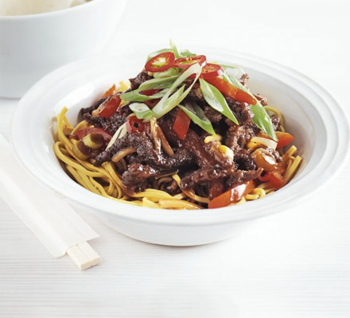
INGREDIENTS
350g thin-cut minute steak, very thinly sliced into strips
3 tbsp cornflour
2 tsp Chinese five-spice powder
100ml vegetable oil
1 red pepper, thinly sliced
1 red chilli, thinly sliced
4 spring onions, sliced, green and white parts separated
2 garlic cloves, crushed
thumb-sized piece ginger, cut into matchsticks
4 tbsp rice wine vinegar or white wine vinegar
1 tbsp soy sauce
2 tbsp sweet chilli sauce
2 tbsp tomato ketchup
cooked noodles, to serve (optional)
prawn crackers, to serve (optional)

METHOD

Put the beef in a bowl and toss in the cornflour and five-spice. Heat the oil in a wok or large frying pan until hot, then add the beef and fry until golden and crisp. Scoop out the beef and drain on kitchen paper. Pour away all but 1 tbsp oil.

Add the pepper, half the chilli, the white ends of the spring onions, garlic and ginger to the pan. Stir-fry for 3 mins to soften, but don’t let the garlic and ginger burn. Mix the vinegar, soy, chilli sauce and ketchup in a jug with 2 tbsp water, then pour over the veg. Bubble for 2 mins, then add the beef back to the pan and toss well to coat. Serve the beef on noodles with prawn crackers, if you like, scattered with the remaining chilli and the green parts of the spring onions.

