Baby-led Weaning

From the very start of their weaning journey babies learn to manage different shapes and textures and as a result become skilled at handling a wide range of foods under your supervision. According to health experts (WHO and Scottish Government) babies should be eating solid food from the age of 6 months as this is around the time their iron stores have ran out and they require extra nutrients that they do not get from their milk. Weaning can be carried out in the traditional weaning method, baby led, or a combination of both. Baby led weaning is where you offer pieces of food to the baby for them to grasp in their hand and feed themselves. The baby controls the amount of solid food they eat by feeding themselves (age appropriate) finger foods or food loaded onto a spoon. As with traditional weaning baby led can be introduced from 6 months, although all babies develop at different rates. A baby should be able to sit up unaided and hold their head well before they are given finger foods.

When preparing the food you need to ensure it is suits the development stage of the baby – need to think about the size and shape of the food being offered, to make sure the baby can pick up, grasp and eat. It is useful to make finger foods slightly bigger than a babies hand so that they can grip it. The size of an adult’s finger is a good guide to go by.

If you choose to do baby led remember that it is controlled by your baby so don’t give into temptation to put the food into their mouth for them. Your role is to let them explore and develop at their own pace, and to provide nutritious food shaped for their developmental stage.

Baby led weaning can:
- Encourage self-feeding from the start of weaning
- Make sure babies set the pace as they lead on how much and how often they eat
- Reduce the time spent preparing foods
- Let babies join in with family meals more easily from the start – mealtimes are made to be a social experience
- If babies aren’t keen on lumps at first finger foods can help them learn to bite and chew
- Help to introduce different flavours and textures. Low sugar finger foods make ideal healthy snacks as well as an important addition to meals

But, there is no scientific evidence that baby led weaning gives babies all the nourishment they need:
- Usually very small amounts of food are taken at first
- There may be a risk of your baby not getting enough iron, especially if meats aren’t offered at the start
- It may be harder to offer a wide variety of foods – not all foods are easily given in finger sized portions and babies may struggle to feed themselves with a loaded spoon at first
- It may make it harder to give breakfast cereals as most are eaten from a spoon. Most breakfast cereals are fortified with vitamins and iron (these are needed from 6 months)

Usually when you begin weaning babies still grasp everything with their fist, so take that into consideration when preparing foods. Remember when preparing finger foods to:
- Take put pips, seeds and stones. Also peel skins at first
- Keep them big enough for your baby to hold. Start with finger sized strips that will stick out from the top of baby’s fist – make sure the pieces aren’t too big, the baby has to be able to close their hand around the food
- As the baby develops their pincer grip, where they can pick up food using their thumb and fore-finger, they will be able to pick up smaller sized finger foods
- Start with finger foods that mash in the mouth. Once they can manage these well move onto other soft finger foods with more texture and then onto firmer foods. Be guided by your baby

How to start baby led weaning:
- Start with soft finger foods (see the table on page 3 for suggestions)
- Your baby must never be left alone whilst eating, they must be seated in an upright position and once they are finished be sure to check their cheeks for any lumps of uneaten food
- Don’t overwhelm them with too many options at the start. It’s a success if they even try just a couple of pieces of food
- Let them pick up the food with their fingers – they will only pick up foods they can manage. At this age their gag reflex is triggered towards the front of the tongue. This is why finger foods are great from 6 months as they can learn to chew and swallow safely
- You don’t have to use plates or bowls when you start out. A lot of the food will most likely end up on the floor. Put the food straight onto their highchair tray (ensure you give it a thorough clean first to get rid of any germs).
- It is important not t rush your baby, try to make them finish a certain amount or eat a specific food. Its up to them how much or little they want to eat. Don’t worry about the amount at the beginning because their milk is still their main source of nutrients.
- The best thing you can do us serve a variety of tastes and textures to get them used to a variety of foods. This will reduce the risk of them becoming fussy as they get older.

Useful Resources:
First Steps Nutrition Trust
Wean the weans
Fun First Foods

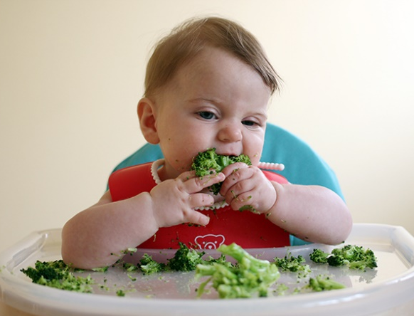

Soft and Easy to chew finger foods are introduced first (usually from 6 months) | Soft finger foods with more texture can gradually be introduced (usually 7 months) | Once baby becomes more experienced with biting and chewing food with firmer texture can be introduced
Avocado | Broccoli | Chicken
soft cooked sweet potato | Potatoes – less soft and can be cut smaller | 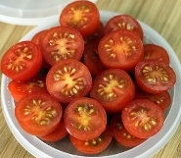  Cherry Tomatoes – remember to cut in half
cooked butternut squash | Tinned peaches | Breadsticks
Cooked carrot | Strawberries | 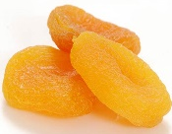  Soft-dried apricot (cut into strips)
Banana | Melon | Cheese
Soft cooked Potato | You can give firmer cereal by adding a little milk to soften | 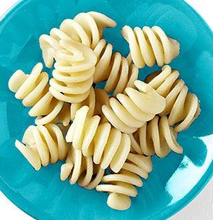  Pasta
 | Boiled egg

Things to remember:
Keep dried fruit to mealtimes. Raisins are not ideal for babies as hard to chew
Make sure cheese is pasteurised
If using tinned fruit ensure they are in fruit juice not syrup

