Pork Meatballs in Red Pepper Sauce
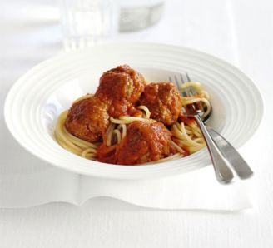
Ingredients
450g pork mince
1 small apple, peeled, cored and grated
1 small garlic clove, crushed
25g fresh white breadcrumbs
1 tbsp olive oil
250g spaghetti, to serve
For the sauce
1 tbsp olive oil
1 onion finely chopped
400g can chopped tomato
3 roasted red peppers (from a jar), roughly chopped

Method

Put the pork mince in a bowl and stir in the apple, garlic, breadcrumbs and some salt and pepper. Shape the mixture into 16 balls, cover and chill for 10 mins.

Meanwhile, make the sauce. Heat the oil in a medium saucepan and add the onion. Cook for 2-3 mins, until softened, then tip in the tomatoes and half a can of water. Stir in the peppers along with some salt and pepper. Partially cover and simmer for 15 mins.

Heat the oil in a large non-stick frying pan and add the meatballs. Cook for 5-6 mins, stirring occasionally until they are browned all over. Set aside and keep warm.

Using a hand-held blender, whizz the tomato sauce until smooth. Carefully add the meatballs to the sauce and simmer for 5 mins, until cooked through. Meanwhile, cook the spaghetti following pack instructions, drain, then divide between serving plates. Top with the meatballs and sauce

